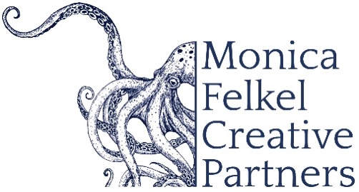

FAWZI HAIMOR, conductor

Ushering in a new era of artistic leadership, Fawzi Haimor is the newly appointed Music Director of the Marin Symphony, a role he assumed in July 2025. He becomes only the fourth Music Director in the orchestra’s distinguished 73-year history. Throughout the 2025–26 season, Haimor will lead nine programs showcasing a compelling range of repertoire—from symphonic masterworks to music by living and historically underrecognized composers—reflecting his deep commitment to both tradition and innovation.

Praised for his “inspiring conducting,” “sensitivity and ability to create a defined, transparent sound,” and his “sense of drama and particular gift for strong, emphatic finishes,” Haimor has led major orchestras across the United States and internationally, including the National Symphony Orchestra, Indianapolis Symphony, BBC Symphony Orchestra, BBC Philharmonic, Edmonton Symphony, and Pittsburgh Symphony.

In the 2025–26 season, he makes his debut with the Calgary Philharmonic and returns to Indiana University’s Jacobs School of Music to conduct a production of Ravel’s L’Enfant et les Sortilèges.

Haimor served as Music Director of Germany’s Württembergische Philharmonie Reutlingen (WPR) from 2107 - 2020, leading the orchestra at their home venue, Stadthalle Reutlingen, and on tour throughout Germany and Europe. Together, they recorded three albums for CPO Records.

Haimor’s extensive international engagements include performances with the Orchestre Philharmonique du Luxembourg, Orchestre de Chambre de Paris, NDR Radiophilharmonie Hannover, Deutsche Radiophilharmonie Saarbrücken Kaiserslautern, Orquestra Sinfónica do Porto Casa da Música, New Zealand Symphony, Orchestra Sinfonica di Milano Giuseppe Verdi, Odense Symphony, Kyoto Symphony, and Qatar Philharmonic, among others.

7/2025

NOTE: Please discard previously dated materials and contact artist’s management before making any alterations or cuts. Please do not use previously dated materials.

